A000-MEX-Monte Albán I-Figurines-500-100 BCE

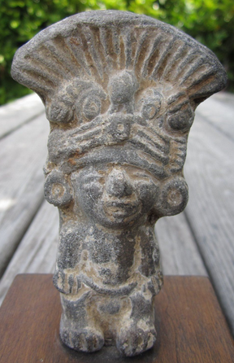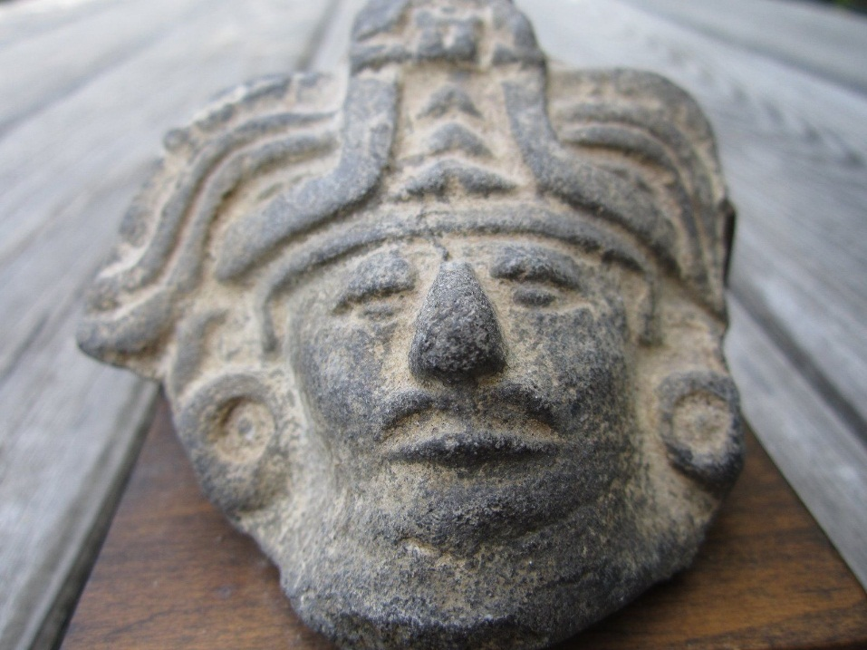

**Case no.: 9**

**Accession Number:**

**Formal Label: Monte Alban Figurines-**

**Display Description:**

This figurine of a Zapotec ruler of Monte Albán was intent upon preserving his control of the sector of Monte Albán. Urban development in Mesoamerica at Monte Alban was initiated 500-450 BCE, and, 100 BCE it was a large economic, political, and religious center with about 17,000 inhabitants. Then by 600 CE the city grew to cover 6.5 square kilometers (2.5 square miles) with a population of about 25,000. More than 2,000 terraces for houses and farm plots covered the hillside below the ceremonial center with a population of 100,000. This was the Zapotec capital city located on a mountain about 1300 feet above the valley floor and at the juncture of three valleys of central Oaxaca. However, this site had no natural source of water, although it did have a strategic placement in the valley.

The building structures included a stone-faced platform with a frontal stairway with flanking balustrades. The buildings were originally stuccoed with painted decorations. Specific buildings are discussed in the pages that follow.

About 170 tombs have been discovered, some with several chambers and some with murals and decorative artifacts, especially ceramic effigies. These magnificent tombs indicate that the rulers of Monte Albán were wealthy and powerful; the offerings in the tombs show evidence of trade with natives to the south in Chiapas and with the growing city to the north at Teotihuacan. Around 800 CE the city declined as the population moved away and the focus of culture moved to other areas. Monte Albán fell into ruins. The ancient town called El Palmillo. was one of many Zapotec towns in the hinterlands of Monte Albán. El Palmillo's influence began to challenge Monte Albán's. About 5,000 people lived there, including farmers, laborers, and artisans. They produced food and crafts from the region's succulent plants like maguey (agave) and exchanged these for goods and services from other settlements. They also built palaces and homes for the nobility, who collected tribute from them, as well as labor. Feinman, the curator of Mesoamerican anthropology at Chicago's Field Museum, and his team have excavated a series of terraces from the base to the top of a hillside to reveal the story of how El Palmillo's social, political, and economic structures changed over time and ultimately collapsed. Local rulers appear to have gained power but then slowly lost it during a process that ended with the almost total abandonment of Monte Albán, El Palmillo, and other large settlements in the Oaxaca Valley. It appears that climate change related to the Neo-Atlantic Altithermal Period (800-1250) initially encouraged the expansion of populations with a longer growing season and a moist climate, but towards the mid-point o this period the rains became fewer and the temperatures increased, spelling the end of favorable conditions for populous cities like Monte AlBán and El Palmillo.

**LC Classification: F1321**

**Date or Time Horizon:** 500-100 BCE

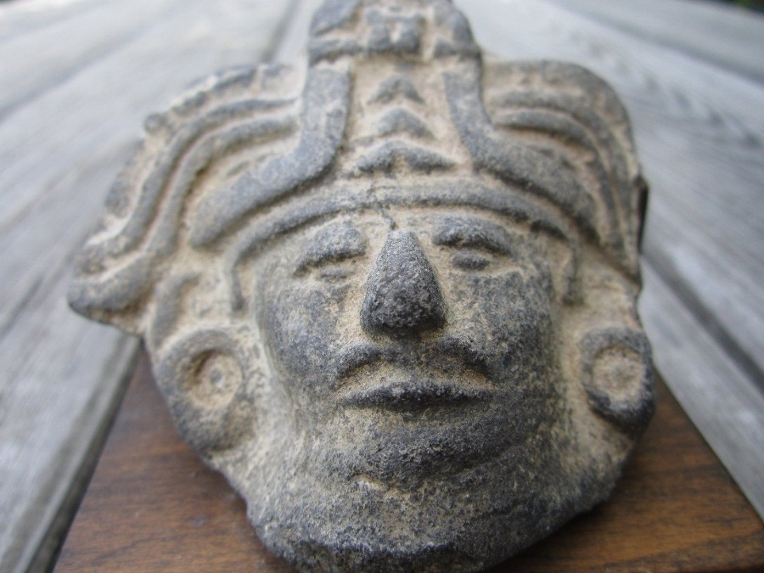

**Geographical Area:**

**Map:**

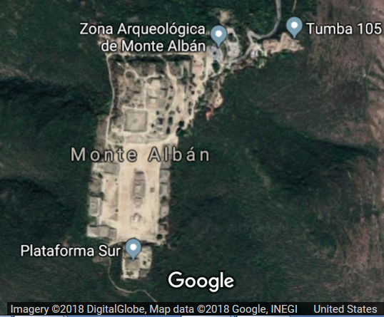

# **GPS coordinates:** 17°02'42.5"N 96°46'12.7"W

**Cultural Affiliation:** Zapotec 500 BCE to 850 CE

**Medium:** ceramic

**Dimensions:**

Standing man: H 4 in,  W 2 5/8 in.      Head of man:  H 3in, Q 3 in.

**Weight:**

**Condition: original**

**Provenance:**

Purchased 1975, near Monte Alban.  Had them mounted in Los Angeles.  Sotheby’s, one of the "Big Three" auction houses stated "The works appear to be authentic."

**Discussion: (from https://whc.unesco.org/en/list/415)**

Monte Alban is the most important archaeological site of the Valley of Oaxaca. Inhabited over a period of 1,500 years by a succession of peoples – Olmecs, Zapotecs and Mixtecs – the terraces, dams, canals, pyramids and artificial mounds of Monte Albán were literally carved out of the mountain and are the symbols of a sacred topography. The grand Zapotec capital flourished for thirteen centuries, from the year 500 B.C to 850 A.D. when, for reasons that have not been established, its eventual abandonment began. The archaeological site is known for its unique dimensions which exhibit the basic chronology and artistic style of the region and for the remains of magnificent temples, ball court, tombs and bas-reliefs with hieroglyphic inscriptions. The main part of the ceremonial centre which forms a 300 m esplanade running north-south with a platform at either end was constructed during the Monte Albán II (c. 300 BC-AD 100) and the Monte Albán III phases. Phase II corresponds to the urbanization of the site and the domination of the environment by the construction of terraces on the sides of the hills, and the development of a system of dams and conduits. The final phases of Monte Albán IV and V were marked by the transformation of the sacred city into a fortified town. Monte Albán represents a civilization of knowledge, traditions and artistic expressions. Excellent planning is evidenced in the position of the line buildings erected north to south, harmonized with both empty spaces and volumes

**References:**

Andrew Coe. 2001. *Archaeological Mexico*. Emeryville, CA: Avalon Travel Publishing.  
Michael D. Coe and Rex Koontz. 2002. *Mexico: From the Olmecs to the Aztecs*. Fifth Edition. London: Thames & Hudson.  
Nelly M. Robles Garcia. 2004. *Monte Albán: History, Art, Monuments*. Mexico: Monclem Ediciones. [official guide]  
INAH. Signage at the site.  
Miller, Mary Ellen. 2001. *The Art of Mesoamerica: From Olmec to Aztec*. Third Edition. London: Thames and Hudson.